Registration Request Form
Photo

- Personal Particulars
Prof./Dr./Mr./Mrs./Ms.
First Name Surname
Gender: Male Female
Date of Birth: DD MM YYYY

Designation:

Affiliated Institution
Address:

Mailing Address:

City: State: Country:

Pin Code: Tel. (ISD/STD code): Fax:

Mobile (Call): Mobile (WhatsApp):

Email:

Nationality: Indian NRI Foreign

Do you need a pickup or drop: Yes No Airport / Railway Station
Arrival Date: (DD/MM/YYYY) Time:
Return Date: (DD/MM/YYYY) Time:
- PSI Membership Details

PSI Membership No.: If not a member, please indicate:
Non-Member Applied for Membership

If applied for membership, specify the membership type:
Life Associate Student

Payment Details to be Enclosed
Registration fee (Rs.): Advance Accommodation (Rs.): Total (Rs.):

Reference / Transaction number:

Dated:

Demand Draft
DD No.:
Amount: Bank:
Date:

Money Transfer NEFT/RTGS
Bank Name:
Branch:
Amount (Rs.):
Date:
- Category of Participation

Invited Speaker Research Scholar Council Member
Chapter Convener Senior Scientist Awardee

Delegate Other (Please Specify)

- Are you submitting a paper: Yes / No. (If yes, Tick sections where paper submitted)

- Cancer, Immunobiology & Metabolic Disorders;
- Biophysics, Neuroscience & Community Health;
- Toxicology, Pharmacology & Reproductive Health;
- Sports, Ergonomics & Occupational Health;
- Microbes in Health & Diseases;
- Food Science & Technology;
- Bioprocess Technology;
- Nanotechnology & Bioinformatics;
- Environmental Biology & IPR;
- Multidisciplinary & Innovative Biology.
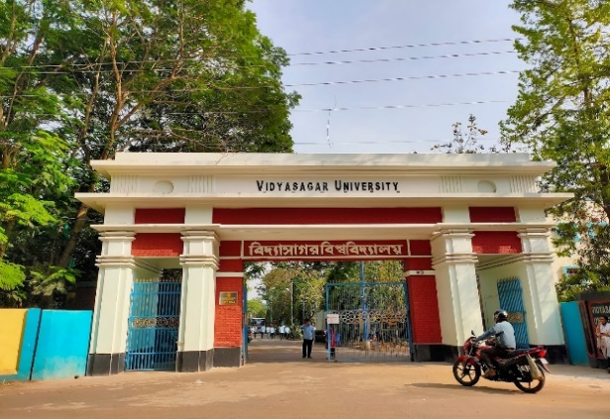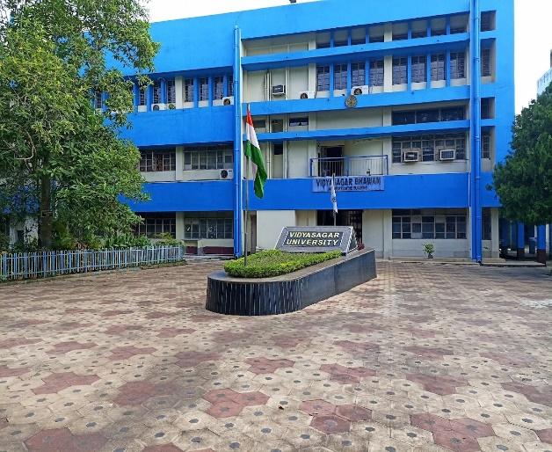
- Accommodation Request Form
Name:
Accompanying Person (Spouse & Kids) Spouse : Kids :
Arrival Date : Time :
Departure Date : Time :
- Category wise rates of accommodation preferred (In University Campus):
Aranyak Guest House
Sl. No. | Occupancy | Tariff / day
1. | AC Double Bed | Rs. -1200/-
2. | Non-AC Double Bed | Rs. - 600/-
3. | Non-AC Single Bed | Rs. - 400/-

Rangamati Guest House
Sl. No. | Occupancy | Tariff / day
 | AC Double Bed (Number of total room -8) | Rs. - 1000/-

- Category wise rates of accommodation preferred (Outside University Campus):
Sl. No. | Name of the Lodge / Hotel | Address with contact details | Occupancy | Tariff / day
 | Prajapati Lodge | Station Road, Midnapore Town, Paschim Medinipur, West Bengal-721101  (Mob.: 8967320081) | a). Non-AC Single  b). AC Single  c). Non-AC Double  d). AC Double | Rs. - 500/-  Rs. - 800/-  Rs. - 750/-  Rs. - 1000/-
 | Lodge Oasis | Keranitola (Station Road), Midnapore Town, Paschim Medinipur, West Bengal - 721101(Mob.:6296504923, 9233311403) | a). Non-AC Single  b). AC-single/ Double | Rs. - 700/-  Rs. - 1500-2000/-
 | Satabdi Lodge | Station Road, Midnapore Town, Paschim Medinipur, West Bengal -721101  (Mob.: 9800063015) | a). Non-AC Single/Double  b). Non-AC triple  c). AC Single/Double | Rs. - 700/-  Rs. - 800/-  Rs. - 1300/-
 | Orbit Hotel | Station Road, Midnapore Town, Paschim Medinipur, West Bengal -721101  (Mob.: 8420033753) | a). Non-AC Single  b). AC Single  c). Non-AC Double  d). AC Double | Rs. - 600/-  Rs. - 1100/-  Rs. - 800/-  Rs. - 1400/
 | Green Palace | Station Road, Midnapore Town, Paschim Medinipur, West Bengal -721101  (Mob.: 7501668577) | a). Non-AC Single/Double  b). AC Deluxe | Rs. -1000-1200/-  Rs. - 2000/-
 | Hotel Hindusthan | Station Road, Keranitola, Midnapore Town, Paschim Medinipur, West Bengal -721101  (Mob.: 7797124777) | a). Non-AC Single  b). AC Single  c). Non-AC Double  d). AC Double  e). AC Deluxe  f). Non- AC Deluxe | Rs. - 300/-  Rs. - 750/-  Rs. - 500/-  Rs. - 995/-  Rs. - 1150/-  Rs. - 700/-
 | Nisantika Lodge | Station Road, Keranitola, Midnapore Town, Paschim Medinipur, West Bengal -721101  (Mob.: 8926896064) | a). Non-AC Single  b). AC Single  c). Non-AC Double  d). AC Double | Rs. - 500/-  Rs. - 850/-  Rs. - 650/-  Rs. - 1150/-
 | Reshma Lodge | Station Road, Midnapore Town, Paschim Medinipur, West Bengal -721101  (Mob.: 9647466777) | a). Non-AC Single  b). AC Single  c). Non-AC Double  d). AC Double | Rs. - 400-800/-  Rs. – 1000-1200/-  Rs. – 800-1000/-  Rs. – 1500-2000/-

- Note:
- Accommodation can be arranged in the Guest House (in university campus) and Hotels (Outside University Campus) at Midnapore Town only on receipt of advance payment, first come first serve basis.

- Accommodation can’t be guaranteed after 15th February 2023.

- Hotel booking is available on first come first serve basis and subject to advance payment directly to the hotel mentioned on above list.

- Shuttle service will be available on fixed timing for movemet from hotel to campus in morning and campus to hotel in the evening.
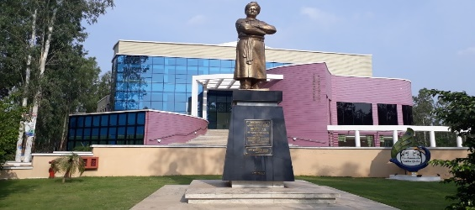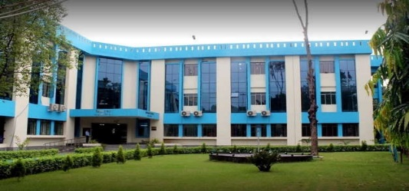
- Travel Request Form
One day tour at Jungle Mahal area (Jhargram & Belpahari):
- Sightseeing: Gadrasini Hill, Khandarani Lake, Ghagra Waterfall, Kanak Durga Temple (Budget – 950/Head).
(Minimum 8 person / Car)
Full Name (in CAPS):
3rd/4th/5th March 2023
Prof./Dr./Mr./Mrs./Ms.

Date of Travel:
- Other General Information
Food Preferred Vegetarian Non-Vegetarian

Date & Place: Signature:
